HANDS-ON EVIDENCE WRITEUP 01 / 04

Windows Sysmon: Process, Network and File Events
  - Objective → test → observed result → SOC interpretation

Objective
Install Sysmon on Windows 11 with SwiftOnSecurity rules; generate and locate Event IDs 1, 3, 11.

Method
Opened PowerShell; created a test account; initiated a Windows-to-Ubuntu TCP/80 connection; created a test text file in Downloads; viewed Microsoft-Windows-Sysmon/Operational.

Evidence
Event 1 shows powershell.exe; Event 3 shows TCP 192.168.56.104:51420 → 192.168.56.101:80; Event 11 shows C:\Users\kesheth\Downloads\Week3_Sysmon_Test.txt.

SOC significance
Process execution, network connection and file creation support process-tree, lateral movement and persistence investigations, but single benign lab events are not malicious indicators by themselves.
sysmon.exe -accepteula -i sysmonconfig-export.xml
Event Viewer → Microsoft-Windows-Sysmon/Operational
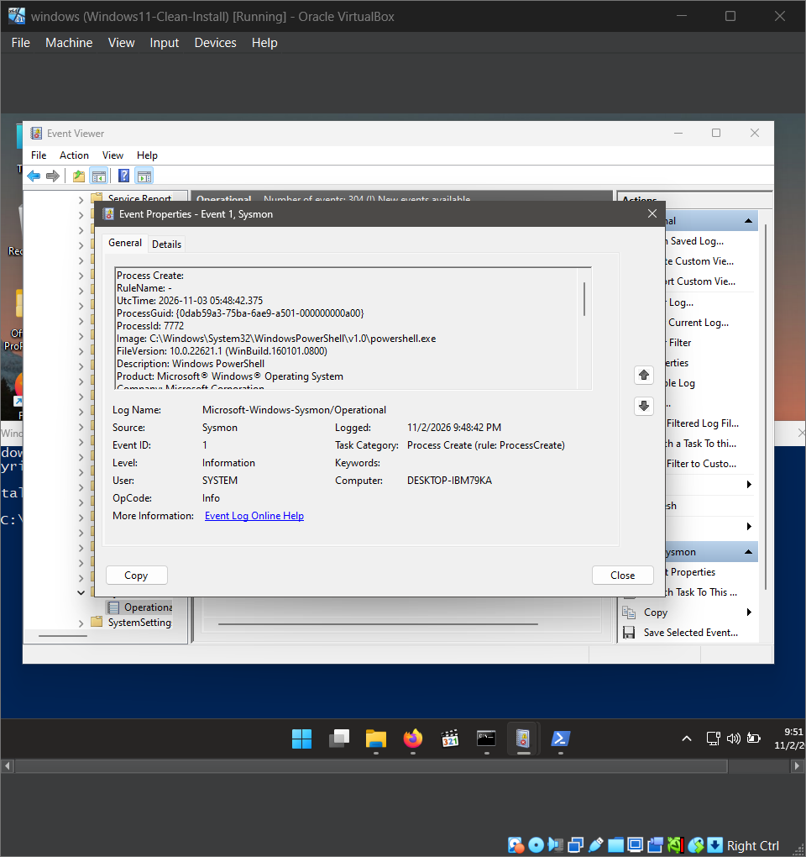
03 Sysmon Event 1 PowerShell
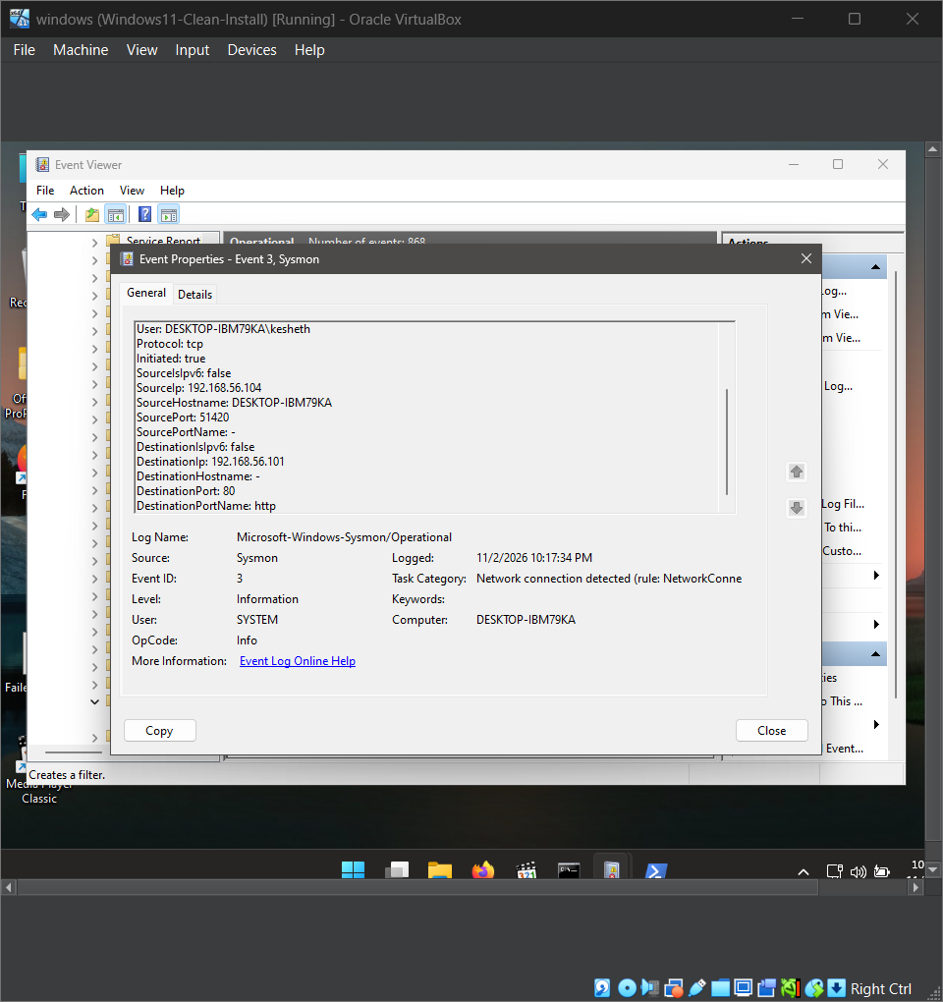
07 Sysmon Event 3 Network Connection
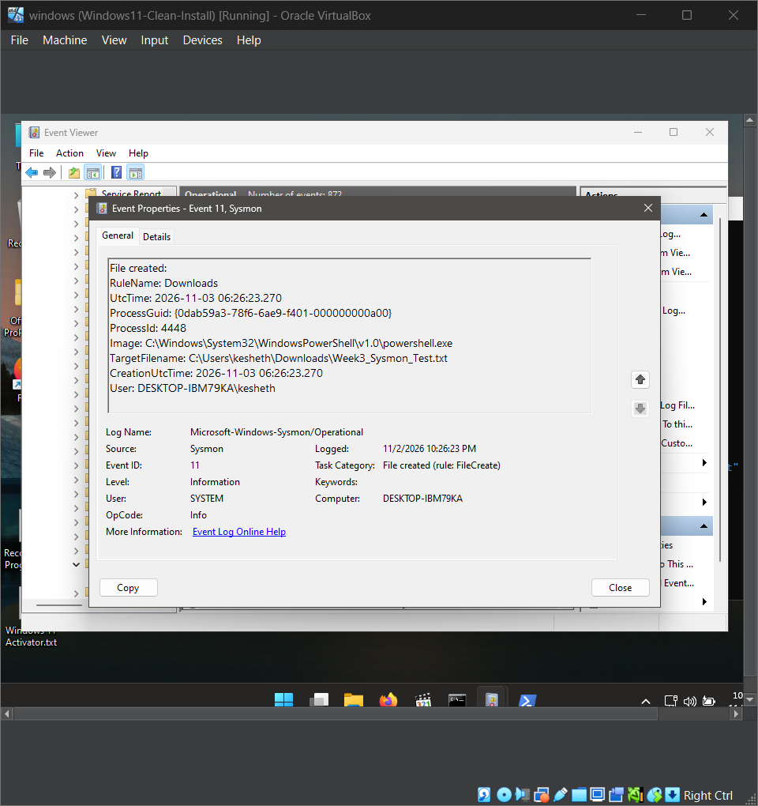
08 Sysmon Event 11 File Creation

